College University API:

TEST

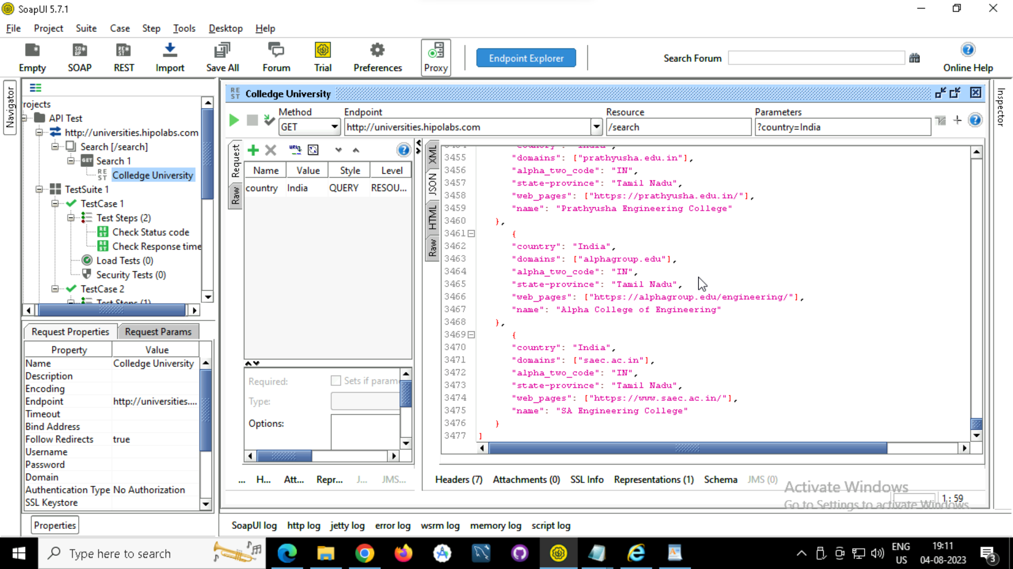

Check Status Code

Check Response Time

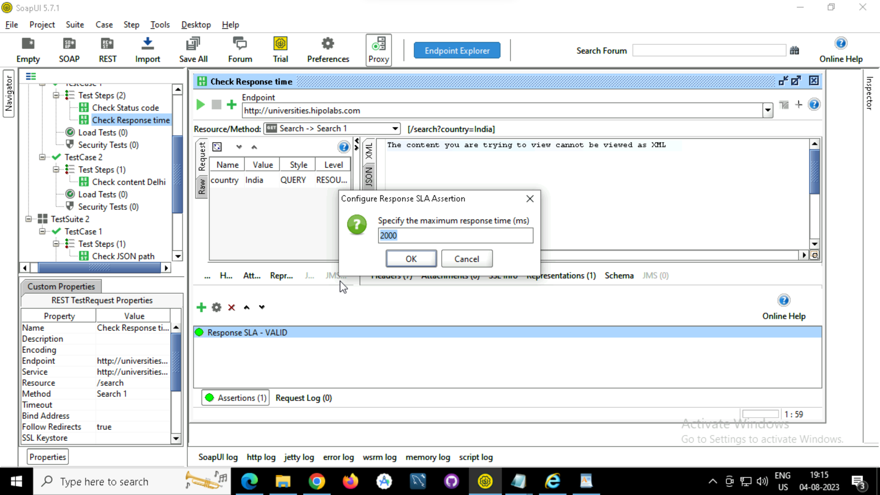

Check Content Delhi

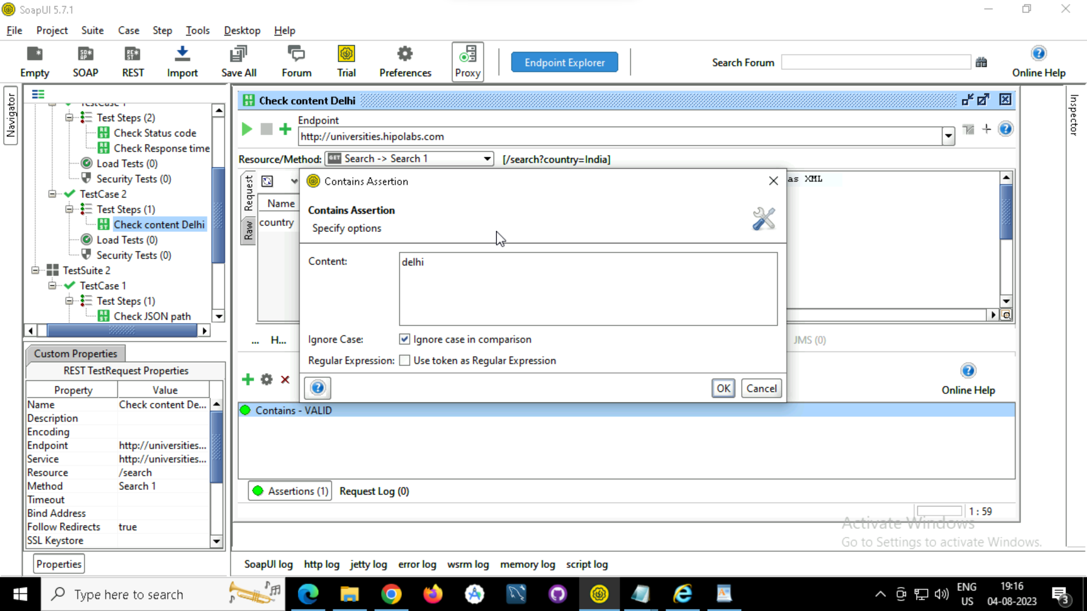

JSON path Validation: IIT Bhubaneshwar

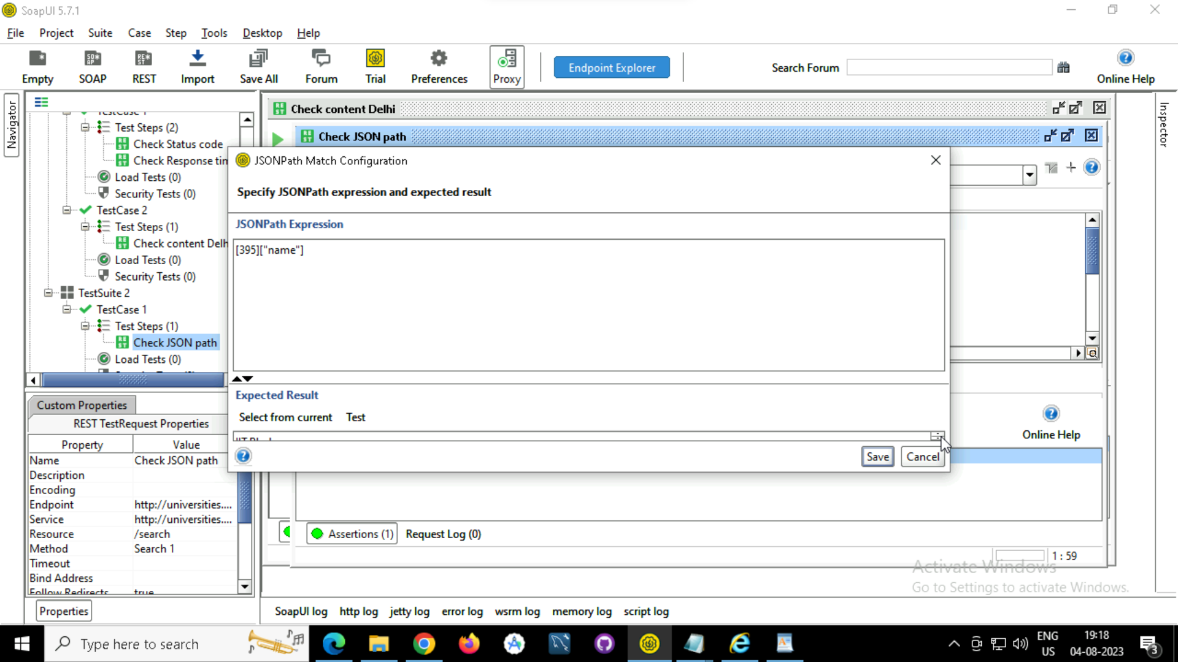

Execute From Step Level:

1

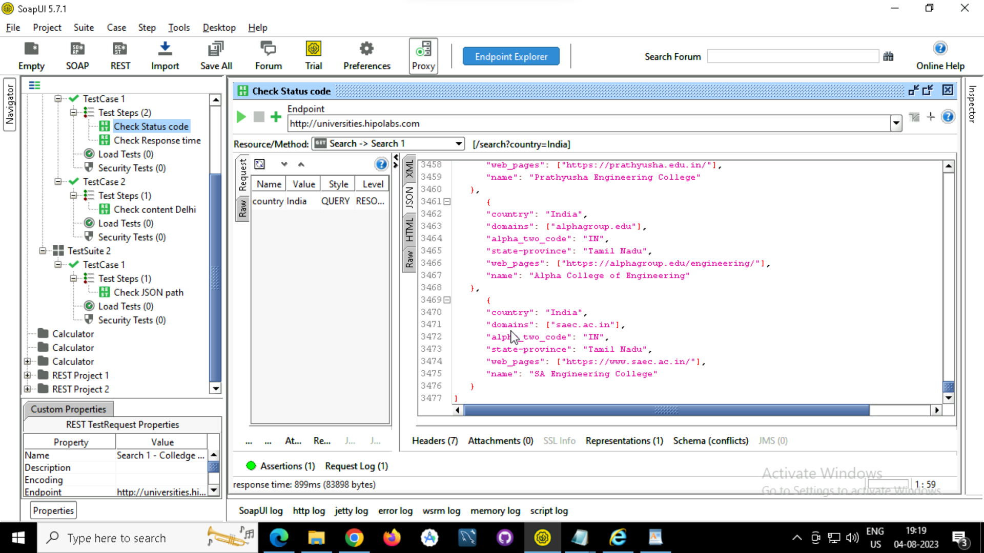

2

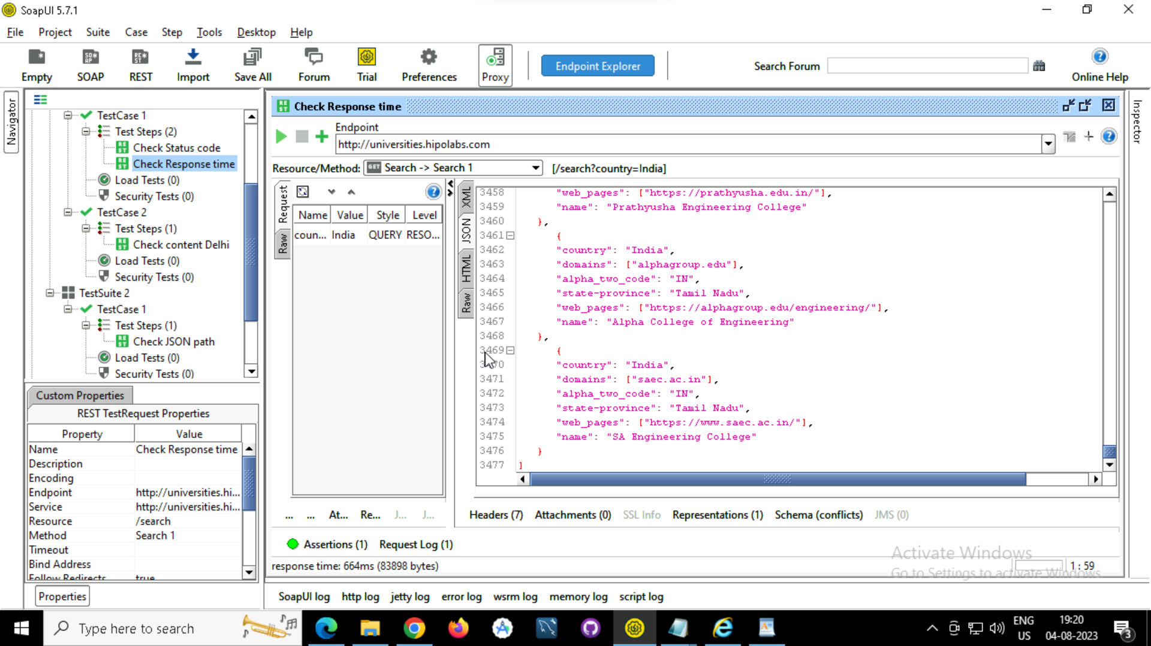

Execute from test case level

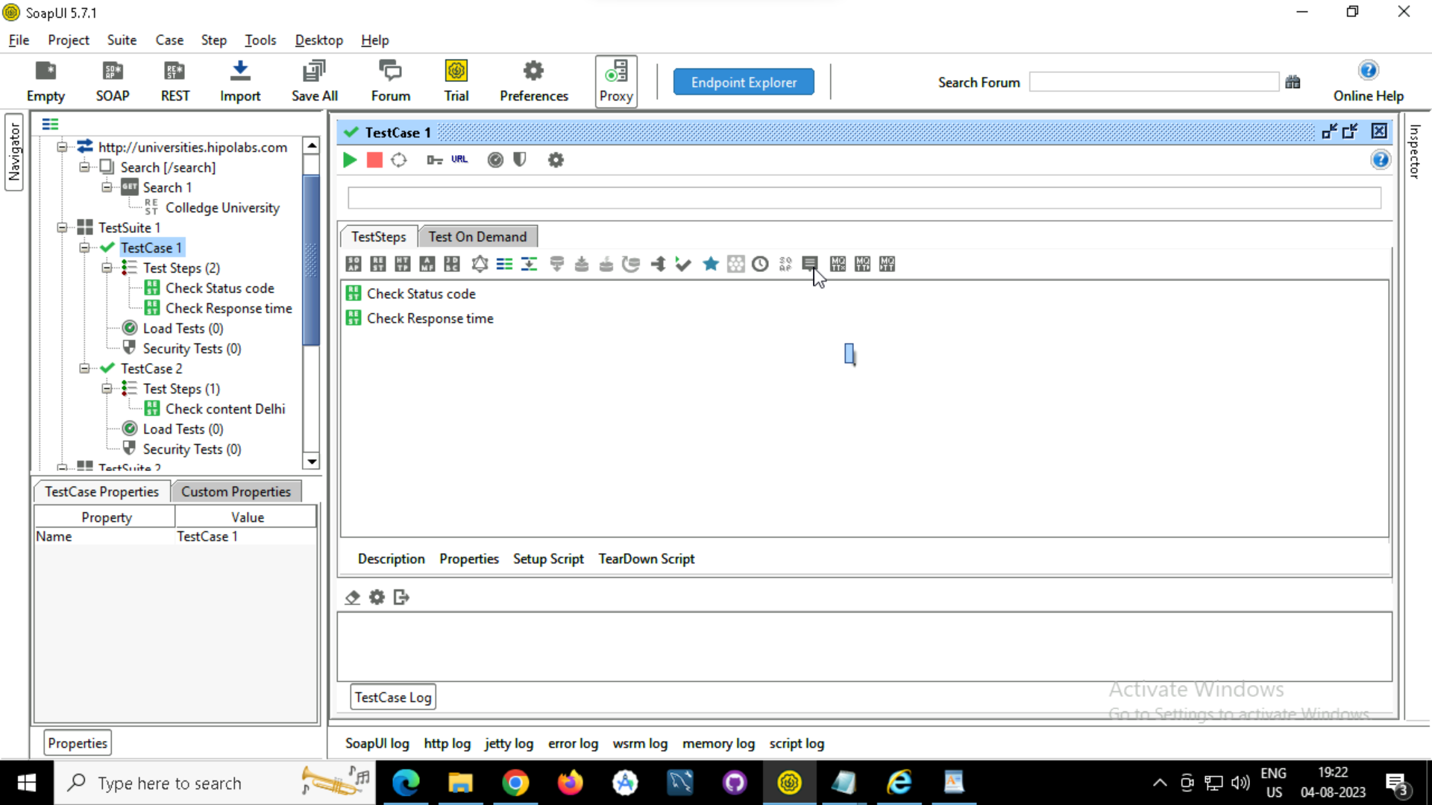

Execute from Suite Level

